 Pegasys
[Credit Card- View Credit Card Log Transactions Reports]

- CRCD Log Transactions—Generates a listing of all Pegasys Credit Card Log (CL,CT) transactions
that have been entered in Pegasys, organized by Approving Official, date, and reconciliation status.
The Approving Official, Credit Card Alias, Date Range, and Reconciliation Status (All Logs or
Unreconciled Logs only) are the parameters entered to generate this report. Note: The Date Range is a
required parameter. The Approving Official and the Credit Card Alias must be entered in the exact
format as shown below. The date range must be entered in the MM/DD/YYYY format. Status can be
selected from a drop-down menu.

Figure 1
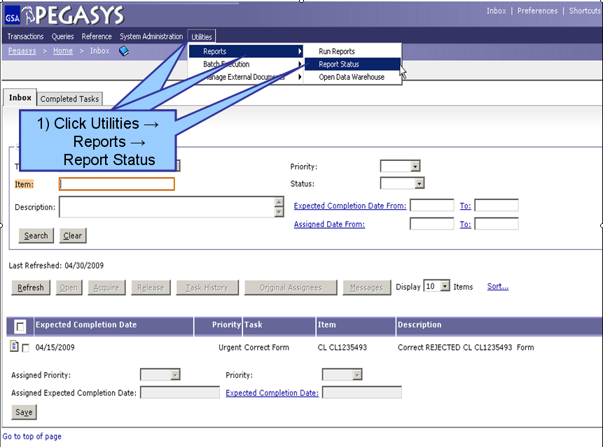
Figure 1

- From the Pegasys homepage, click on Utilities on the Menu Bar
- Click on Reports.
- Click on Report Status.

**Report Status Maintenance is displayed for all processing and/or completed reports**

Figure 2
Figure 2

- To find a report, the user can search by Report Subsystem. Enter all known information. (Step 1)
- Click Search. (Step 2)
- When the results are returned, select a report from the populated field. (Step 3)
- Click Details after the report is selected. (Step 4)
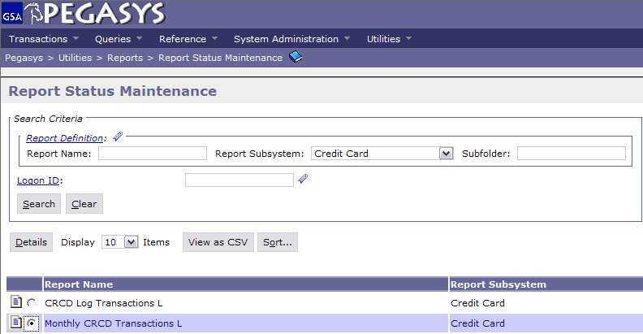
1) Search by:
Subsystem
2) Click Search
3) Select the Report
4) Click Details
(OVER)

Figure 3
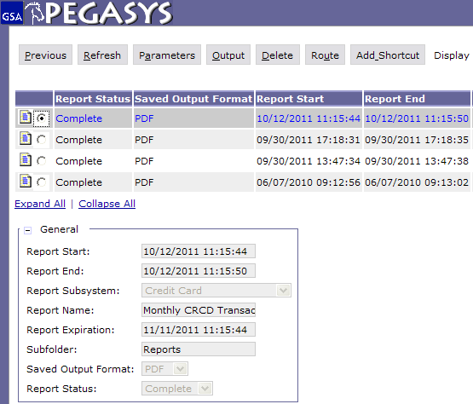
2) Click Output
1) Select the Report
Figure 3

- On the Report Executions page, select the report to be viewed. (Step 1)
- Click Output after the report has been selected to view the report as a PDF file. (Step 2)

